03/11/2021
Privacy Policy for the Nevada Bank & Trust Card Manager Services (Effective 03/11/2021)
- Introduction. This Privacy Policy describes the types of “Personal Information” (information that is identifiable to a particular person) that is collected (directly or through service providers) in connection with the Nevada Bank & Trust Card Manager downloadable application (“App”) and related services (collectively, the “Service”) offered by your financial institution (“we” or “us”). This Privacy Policy is intended to supplement the disclosures in any Privacy Policy that you may have already been presented by us in connection with online banking or other services.

- Eligibility. The Service is offered only to individual residents of the United States, excluding its territories, who can form legally binding contracts under applicable law. Without limiting the foregoing, the Service is not offered to minors. Other restrictions and eligibility requirements for the Service apply as described in the Nevada Bank & Trust Card Manager Terms of Use. We do not knowingly collect any Personal Information from or about individuals under 18 years of age. Please do not submit such information to us, and as a parent or legal guardian, please do not allow your children to submit Personal Information without your permission. By using the App or the Service, you represent that you meet these requirements and that you agree to the terms of this Privacy Policy.

- What Types of Personal Information We May Collect. We may collect Personal Information about you, which may include: name, postal address, zip code, e-mail address, telephone number, account numbers, payment card expiration date, payment card identification or verification numbers, social security number, mobile device location, and other information that we can use to contact you, verify your identity, provide the functionality available through use of the App and the Service, and manage risks such as information maintained about you by identity verification services and consumer reporting agencies, including credit bureaus, and payment and other transaction information, and history for payments and other transactions in which you participate through the service, and any Personal Information that you may enter into information blocks present in the App interface or made available through the Service.

- How We May Collect Personal Information About You. We may collect Personal Information about you from the following sources:

  - Information that you input into the App or that the App collects automatically;

  - Your use of the App and the Service, and your interactions with customer care, including information you enter or speak, and information transmitted by your computer or mobile device or other devices you use as a part of your receipt of the Service; and

  - We may also collect Personal Information about you from others, such as Affiliates, or other companies (such as for fraud detection).

- How We May Share Personal Information About You. We share Personal Information about you only as permitted by law. For Personal Information that is nonpublic and that we collect in connection with a financial service, U.S. federal law permits us to share such information only for the purposes shown in the following table:

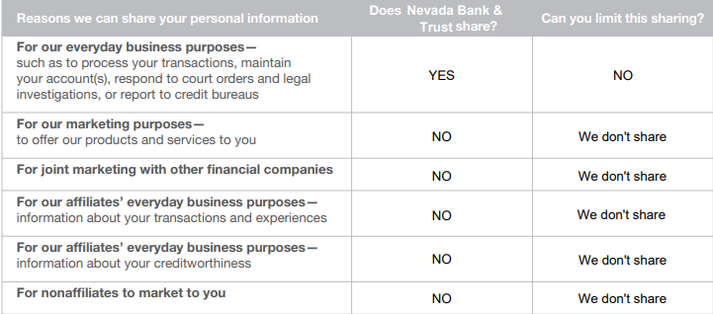

- How we May Use Personal Information About You. We use Personal Information about you only as permitted by law, including but not limited to the following purposes:

  - To complete transactions and render services authorized by you;

  - Other everyday business purposes, such as to maintain your ability to access the Service, to send you information about the Service, to effect, administer and enforce transactions, to perform fraud screening, to prevent actual or potential fraud and unauthorized transactions, to verify your identity, to determine your credit history, to verify the information you provide to the Service, to perform collections, to report to credit bureaus (including furnishing delinquent account information), to comply with laws, regulations, court orders and lawful instructions from government agencies, to protect the personal safety of users of the Service or the public, to prevent and defend claims, to resolve disputes, to troubleshoot problems, to enforce our Terms of Use, to protect our rights and property, and to customize, measure, and improve the Service and the App, including pattern recognition, modeling, enhancement and improvement, system analysis, and Service performance analysis;

  - For marketing purposes- to offer products and services to you, although you may opt-out of receiving commercial email marketing messages from us by following the opt-out process described in those messages; and

  - If we are involved in a merger, acquisition, or sale of all or a portion of our assets that results in a change of the majority ownership of the App or the Service or the entity that owns them, you will be notified of this via email and/or a prominent notice on the App, as well as any material change in the uses of your Personal Information, as well as any choices you may have regarding Personal Information about you.

- Other Important Information.
Vermont: Under Vermont law, we will not share information we collect about Vermont residents with companies outside of our Affiliates, unless the law allows. We will not share information about your credit worthiness with our Affiliates except with your consent, btu we may share information about our transactions or experiences with you with our Affiliates without your consent.

California: Under California law, we will not share information we collect about you with Nonaffiliates, unless the law allows. For example, we may share information with your consent, to service your accounts, or to provide rewards or benefits you are entitled to. We will limit sharing among out Affiliates to the extent required by California law.

- Definitions.

  - “Affiliates” means companies related by common ownership or control. They can be financial or nonfinancial companies.

  - “Nonaffiliates” means companies not related by common ownership or control. They can be financial or nonfinancial companies.

  - “Joint Marketing” means a formal agreement between nonaffiliated financial companies that together market financial products or services to you.

- How We Protect Personal Information About You. To protect Personal Information about you from unauthorized access and use, we maintain physical, electronic, and procedural safeguards, including but not limited to security measures that comply with applicable federal and state laws. We also require our service providers and business partners to whom we disclose information to do the same. When you enter sensitive information (such as debit or credit card number) into the App, we encrypt the transmission of that information using secure socket layer technology (SSL). We may retain and use your information as necessary to comply with our legal obligations, resolve disputes, and enforce our agreements.

- Data Retention. We will retain, protect, use and share Personal Information about you as long as it is reasonable required for the purposes described in this Privacy Policy, and as required by law, including but not limited to for risk management, regulatory compliance, and audit purposes.

- Amendments. We may amend this policy at any time by posting a revised version of the App. The revised version will be effective immediately at the time it is posted unless a delayed effective date is expressly stated therein. You may (in our discretion) also be provided with an email notification of such amendments. If we make any change in how we use our Personal Information, we will notify you by email or by means of a notice in the App prior to the change becoming effective. You may (in our discretion) be required to affirmatively acknowledge or accept the revised Privacy Policy in order to continue using the App and the Service. Any use of the App of Service after a notice of change will constitute your express agreement to such changes.

- Contacting Us. If you have any questions about this Privacy Policy or wish to provide updates or corrections to information about you, you may contact us by calling us at the phone number, or writing to us at the address, of our main offices.

